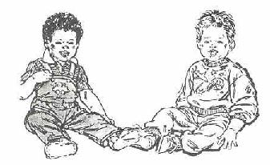

YOUR INFANT’S HEARING SCREEN

Why is my baby’s hearing important?
Hearing impairment in infants is easy to ignore because it is invisible and an infant or toddler cannot tell us they are unable to hear. However, the most critical years for the development of language are from birth to three years of age. Babies learn by listening. If a child is unable to hear normally, speech and language will not develop normally. Early identification of hearing impairment enables us to give the child the special attention needed to aid in language development as well as social-emotional and educational development.

How can my baby’s hearing be tested?
Our audiologists use two procedures to test your baby’s hearing:
- The procedure called Auditory Brainstem Response (ABR) utilizes sound presented to your baby’s ears through tiny earphones. Electrodes that resemble stickers then pick up the response from the ears and send it to a computer where it is stored. Each ear is tested separately and a pass/refer determination is made by the audiologist.
- The procedure called Otoacoustic Emissions (OAE) utilizes sound presented to your baby’s ears from probes placed in the ear canals which then measure echoes from the inner ear. Each ear is tested separately and a pass/refer determination is made by the audiologist.

What does “pass/refer” mean?
A “pass” determination means the tested ear responded normally while a “refer” determination means that additional testing is needed.

What happens if my baby is referred for additional testing?
If a referral is indicated, further audiological evaluation is necessary.

How long does testing take?
A screening takes approximately 15 to 30 minutes provided that the baby is quiet. A diagnostic evaluation takes approximately two hours. Ideally, the best test results are obtained when the baby is sleeping. Therefore, we ask that you bring your baby to our office for this appointment during naptime or in a sleepy state.

Is testing painful to my child?
No. These tests are completely non-invasive and most infants sleep through them.

How can I tell if my baby has a hearing problem?
An audiologist is the professional trained to assess your baby’s hearing and can test him or her as early as a few hours of age. The audiologist will thoroughly discuss all test results and recommendations with you.

What can I do if a hearing impairment is identified?
Intervention depends on the type of hearing impairment identified. The audiologist will work closely with your pediatrician and other appropriate professionals to provide the best possible care. If your baby requires hearing aids and/or other assistive devices, it is ideal that the aids be fit before six months of age and that follow-up and rehabilitation be initiated accordingly.

